BITS Pilani -PG Certification in AI & ML
Capstone Project -Week 1 Submission
Topic: AI Based Legal Contract Risk Assessment

1. Problem Statement

Nowadays companies deal with a lot of contracts like loan agreements, payment terms, BNPL contracts etc. These contracts are usually very long and written in complicated legal language. So reading them manually is very difficult and time consuming.

The problem is that lawyers have to read each contract fully to find out if there are any risky clauses. This takes many hours and is also very expensive. Also sometimes due to the length of the contract important risky parts get missed.

So our project idea is to use AI and NLP to automatically read these contracts and highlight the risky clauses. This will save time and reduce human error.

In simple words -the system will read the contract, understand the clauses, and tell the lawyer which parts are risky and why.

High Level Architecture of the System
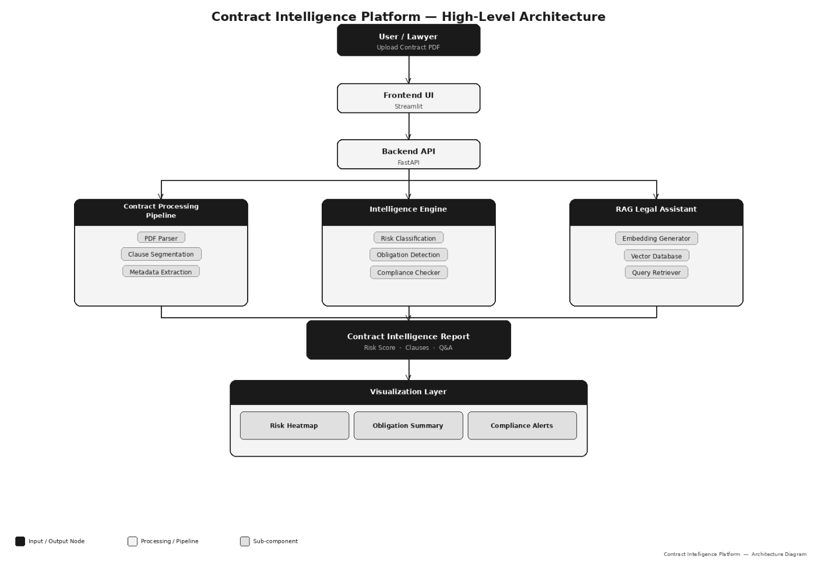

2. Use Case Document

Who will use this system?
- Lawyers and legal teams in companies - they can use it to do faster contract review
- Fintech companies -to check if their contracts are following RBI or other regulations
- Banks and lending companies -to check loan agreements before signing
- Small businesses -who cannot afford expensive lawyers for every contract

Main Use Cases

Use Case | What it does
Loan Agreement Check | Reads loan contracts and finds risky repayment or penalty clauses
BNPL Contract Review | Looks for hidden auto-debit or charges in BNPL agreements
Payment Processing | Finds liability and chargeback clauses in merchant agreements
Crypto Contracts | Checks for jurisdiction and collateral risks in digital asset contracts
Compliance Check | Flags clauses that may not follow RBI or SEC guidelines

How the system will basically work
Step 1 -User uploads or provides the contract
Step 2 -System breaks it into smaller parts / clauses
Step 3 -AI model reads each clause and classifies the risk
Step 4 -A risk score is given (low / medium / high)
Step 5 -Final report is shown with all risky clauses highlighted

We will explore more detailed flow in coming weeks once we start building the model.

3. Dataset

For our project we have collected 20 real contracts. We did not create these contracts ourselves, we found them on SEC EDGAR which is a public US government website where companies upload their legal filings. We also took 2 contracts from Indian fintech companies Razorpay and LazyPay.

Total contracts -20
Source -SEC EDGAR (18 contracts) + Indian fintech portals (2 contracts)
These are all publicly available so there is no copyright issue.

Contract Groups

Group 1 -Loan Agreements (5 contracts)
- LendingClub Loan Purchase Agreement
- FinTech Revolving Credit Agreement
- Amended and Restated Loan Agreement
- Auto Loan and Servicing Agreement -Credit Acceptance
- XPEL Credit Agreement 2023 -Wells Fargo

Group 2 -BNPL and Installment Finance (4 contracts)
- Affirm Merchant Agreement
- Affirm Amazon Installment Agreement
- Revolving Loan Agreement -Auto Finance
- Bank Loan with Auto Debit Clause

Group 3 -Payment Processing (4 contracts)
- Electronic Payment Processing Agreement
- Merchant Card Processing Agreement -Cash Systems
- Merchant Program and Bank Clearing Agreement
- Credit Card Processing and Settlement -WMG

Group 4 -Crypto and Digital Assets (3 contracts)
- Digital Currency Loan Agreement -Galaxy Digital
- Revolving Credit with Crypto Collateral
- AMD Credit Agreement -Digital Payments

Group 5 -Investment and Advisory (2 contracts)
- Investment Credit Facility -UBS + China Merchants Bank
- Third Amended Credit Agreement -DCP Midstream

Group 6 -Indian FinTech (2 contracts)
- Payment Processing Terms -Razorpay
- BNPL Terms and Conditions -LazyPay

Note -for week 1 we are just identifying and listing the contracts. We will extract and process the actual text in week 2 onwards.

4. Industry Pain Points and System Vision

Pain Points
After doing some research we found these are the main problems in the industry right now –

- Manual review is very slow -one contract can take 4 to 8 hours easily
- Very expensive -lawyers charge a lot per hour so reviewing many contracts costs a lot
- Human error -when reading long contracts manually people miss things
- No scalability -if a company has 500 contracts a month the legal team cannot handle it
- Regulatory risk -if a risky clause is missed company can get penalized by RBI or SEC etc

Our System Vision
We want to build a simple but useful system that solves the above problems. The idea is –

- Take any financial contract as input
- Use NLP to split it into clauses and understand the meaning
- Classify each clause into risk category
- Give a simple risk report at the end

We are planning to use Legal BERT or similar pretrained model for the NLP part. We will fine tune it on our dataset of 20 contracts. More details will come in later weeks.

The end goal is that a lawyer should be able to upload a contract and within a few minutes get a report showing exactly which parts are risky. This will save a lot of time and money.

5. Week-wise Plan

Week | What we plan to do
Week 1 | Problem statement, use cases, dataset collection (current week -done)
Week 2 | Extract text from contracts, start labeling risky clauses manually
Week 3 | EDA and basic model (keyword based or simple ML)
Week 4 | Train NLP model using Legal BERT
Week 5 | Risk scoring and testing
Week 6 | Build simple UI and generate sample reports
Week 7 | Final demo and presentation

